Major Assignment

Milestone 1:

1.a.

Calculate Monthly average NAV, Repurchase & Sale Price for each scheme.

Query:

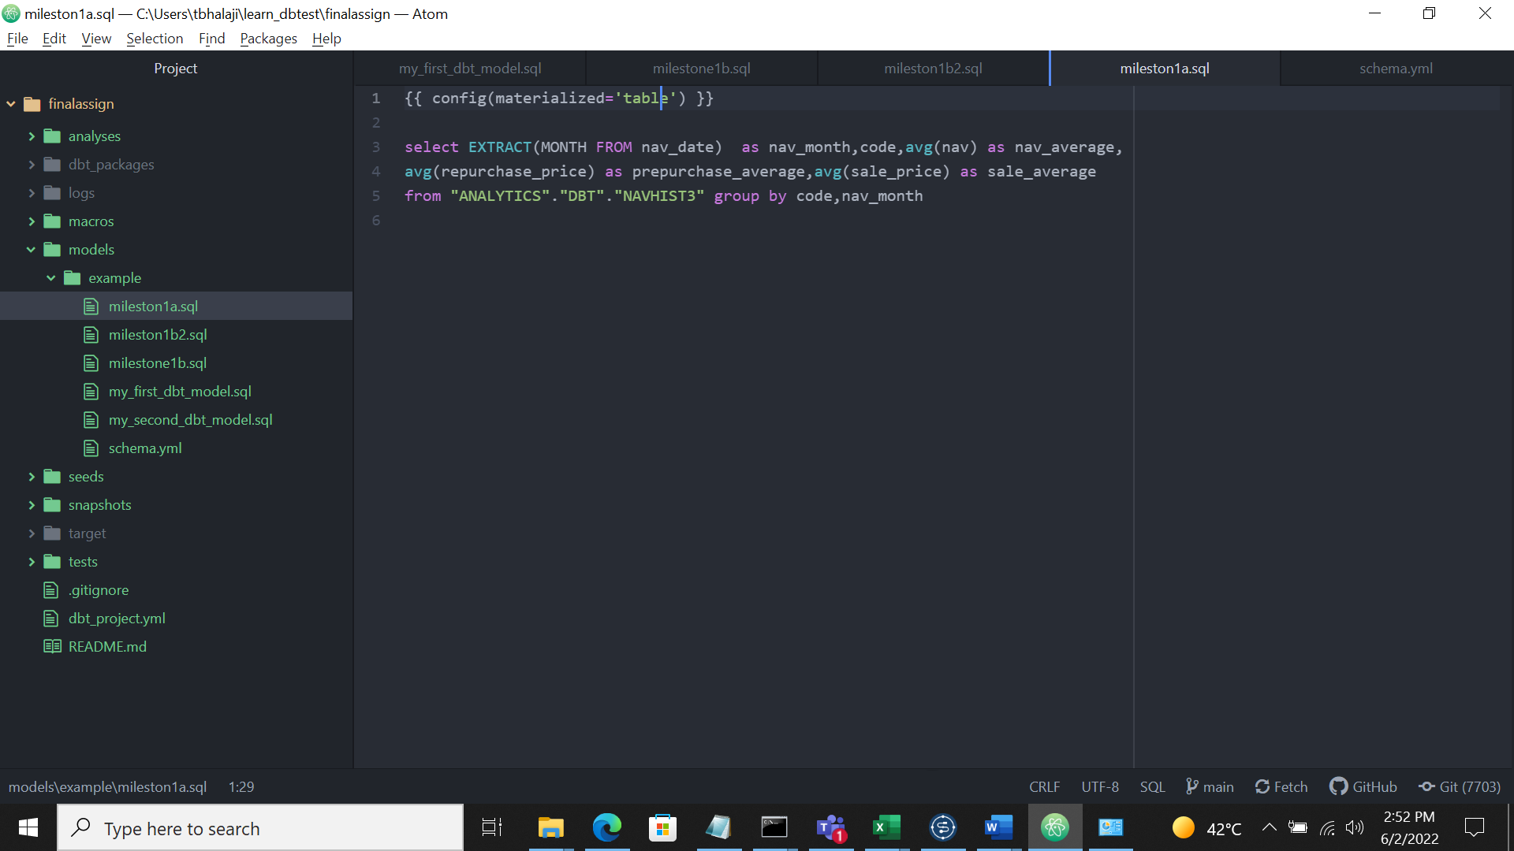

Command : dbt Run

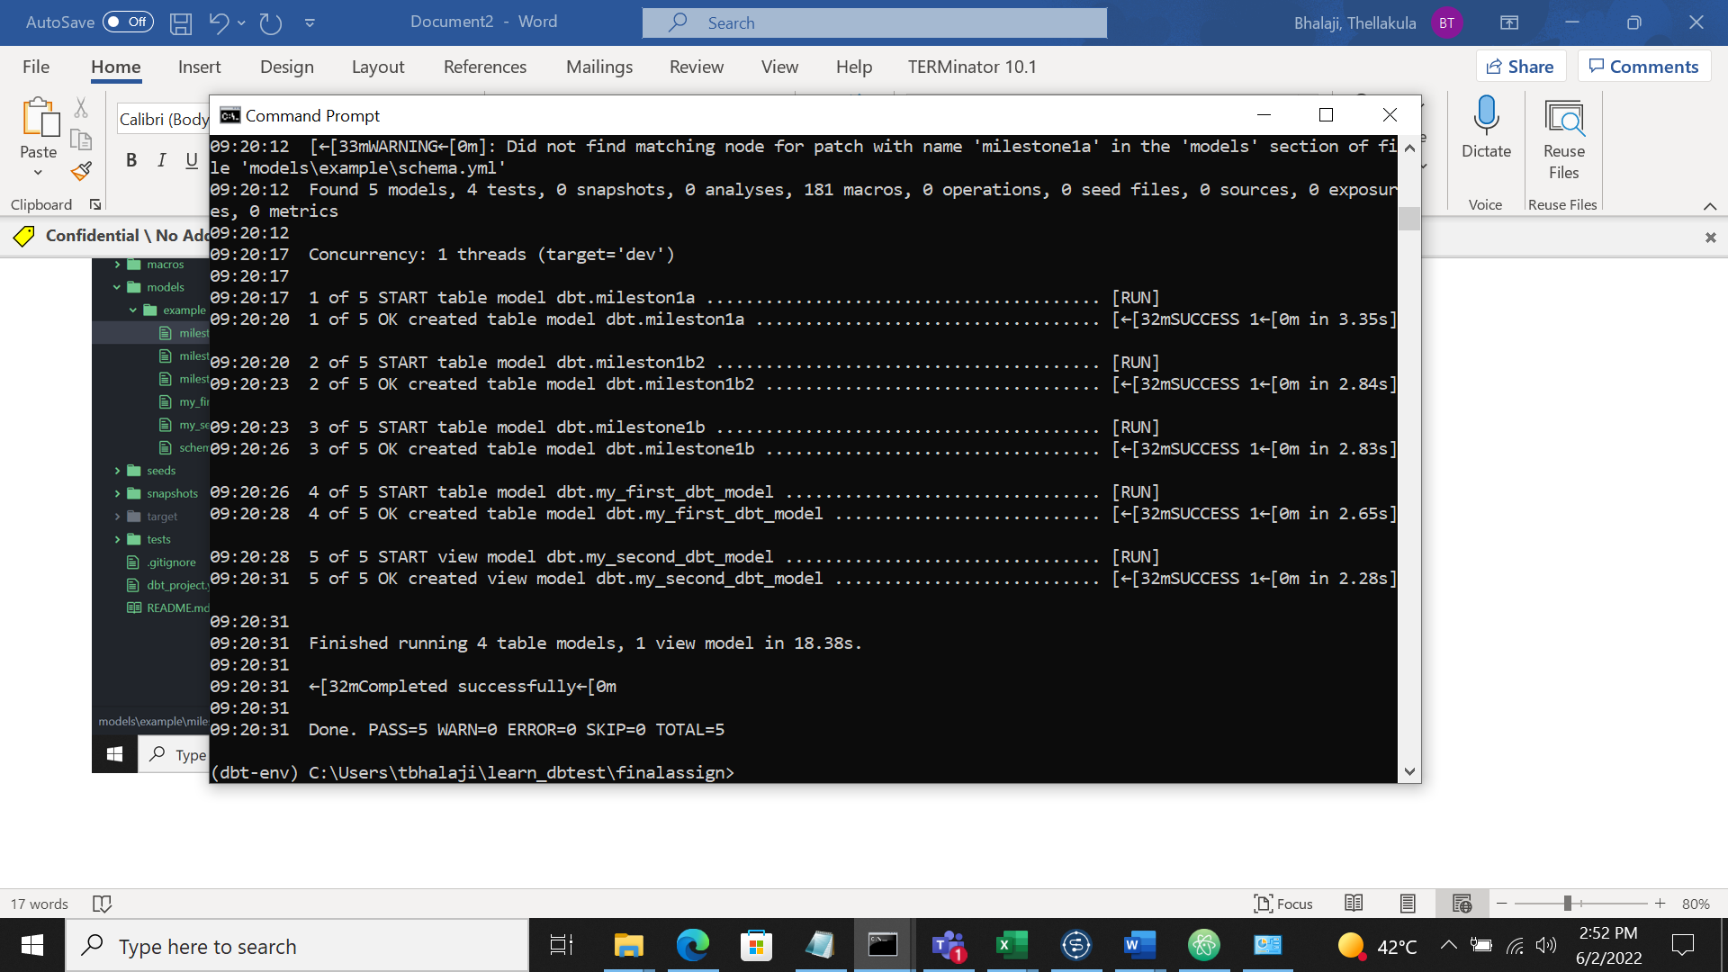

1.b.1.

Find out each scheme’s Max and Min NAV value and Date it occurred

Query:

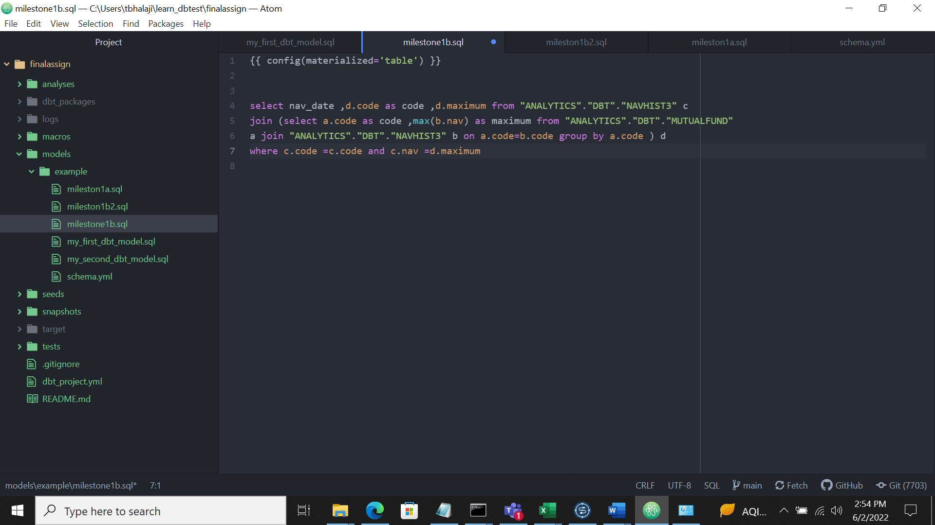

Command : dbt Run



1.b.2.

Find out each scheme’s Max and Min NAV value and Date it occurred

Query:

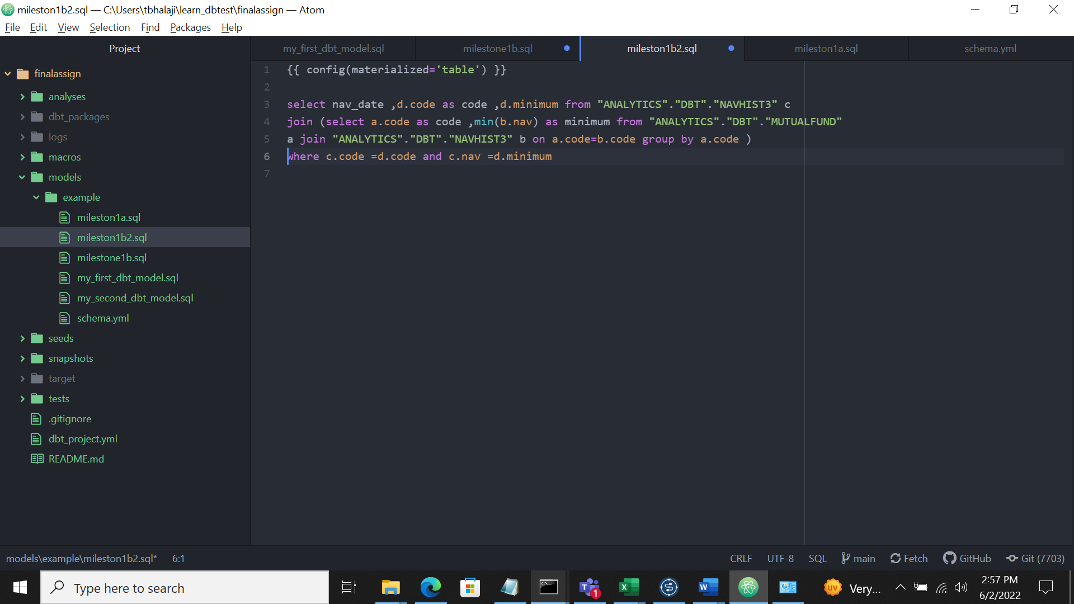

Comamd:dbt run

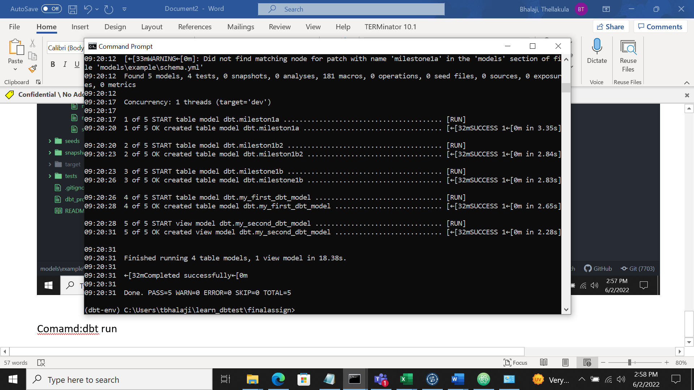

Tables created in snowflake:

